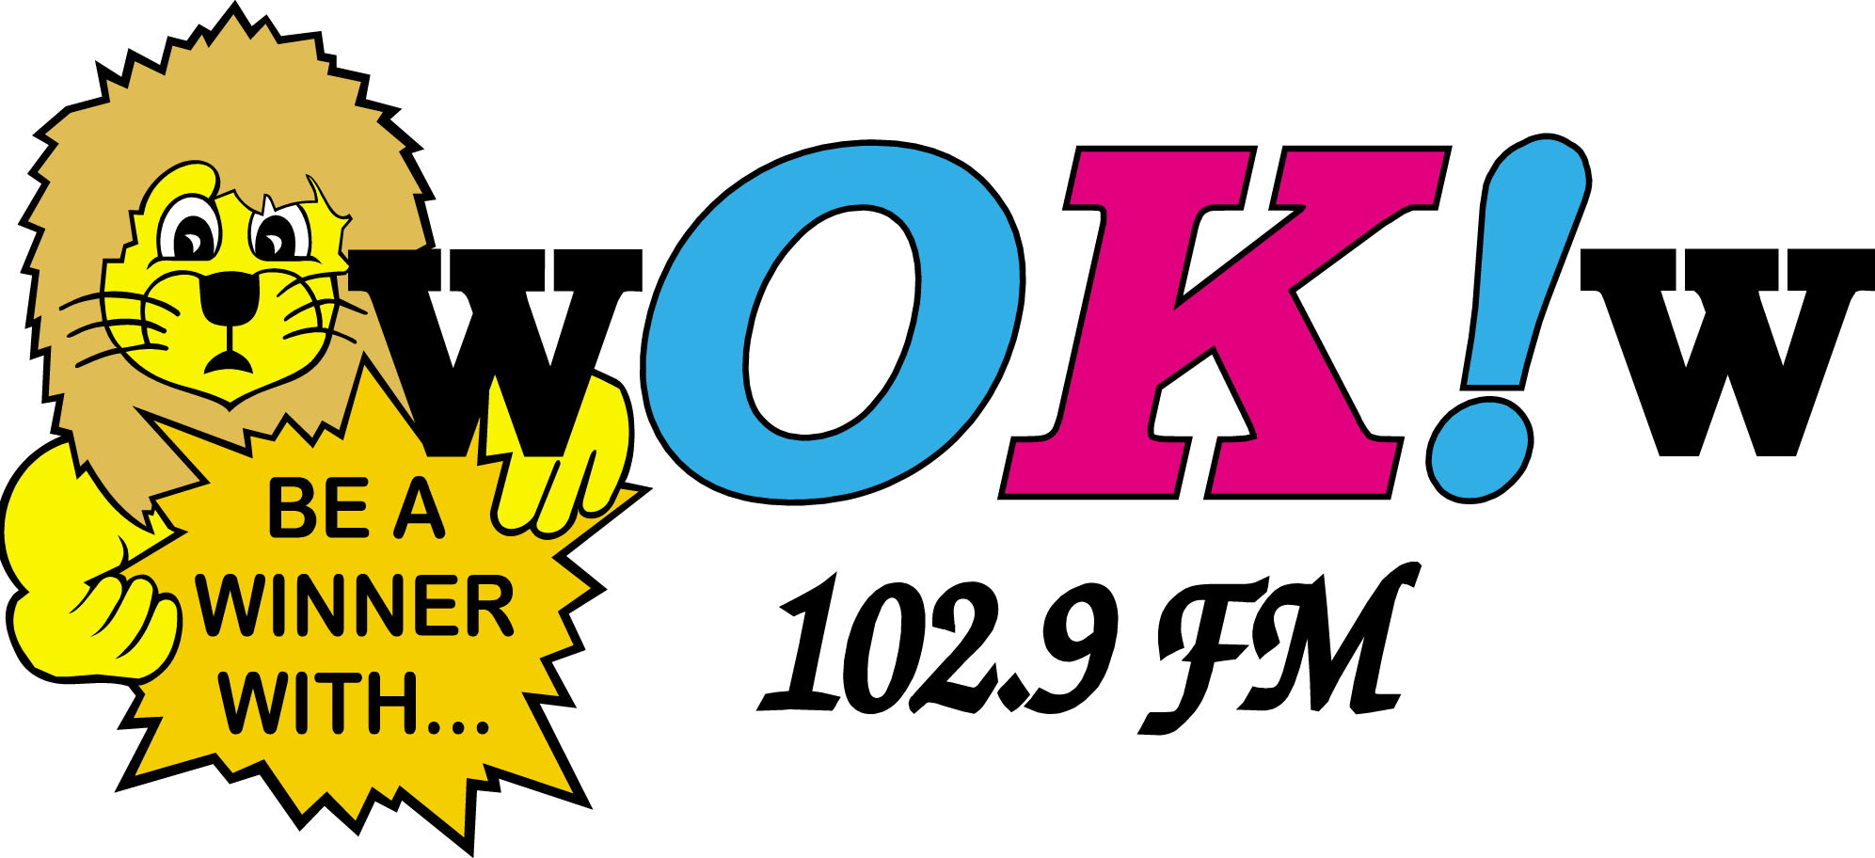

Monday through Sunday 6 am- 12mid

Ads Per Week | 1 to 13 | 14 to 20 | 21 to 27 | 28 to 34 | 35 +
60 second ads | $13.00 | $12.00 | $11.00 | $10.00 | $9.00
30 second ads | $10.50 | $9.50 | $8.75 | $8.00 | $7.00
15 second ads | $5.50 | $5.50 | $5.50 | $5.50 | $5.50

Monday through Sunday ads 12mid- 6am

Just 15% of your daytime rate

++++++++++++++++++++++++++++++
Yearly Bulk Contracts
60 Second Ads 30 Second Ads

364 x $12.00 364 x $9.50
500 x $11.00 500 x $8.75
750 x $10.00 750 x $8.00
1000 x $9.00 1000 x $7.00
+++++++++++++++++++++++++++

All rates are NET to station * Add 15% for Fixed Times
Specials packages available for Bulk Contract Advertisers

Ads will play on WOKW 102.9FM and stream at www.wokw.com

