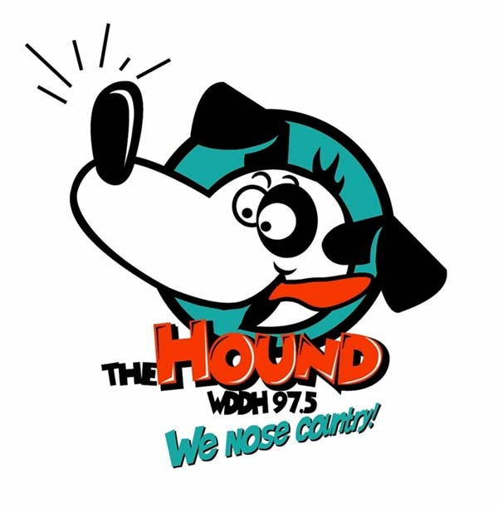
TODAYS BEST COUNTRY &
YESTERDAY’S FAVORITES

Delivering thousands of listeners in 16 counties in
North Central Pennsylvania & Southwestern New York

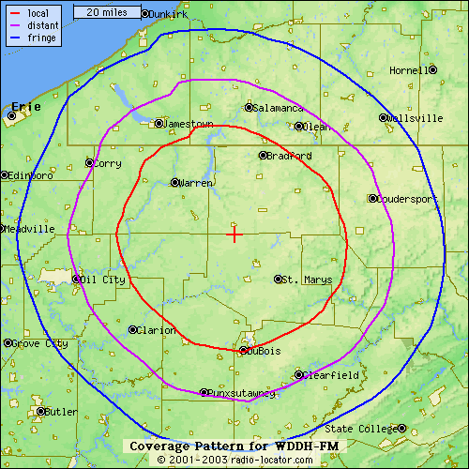
COVERAGE MAP

PO BOX O ~ 14902 BOOT JACK RD. ~ RIDGWAY, PA 15853 ~ 814-772-9700 ~ 814-772-9750 FAX
STREAMING LIVE AT www.houndcountry.com CHECK US OUT!
STREAMING LIVE AT www.houndcountry.com CHECK US OUT!

